APS PA DAY MONDAY APRIL 8
APS WILL BE OPEN
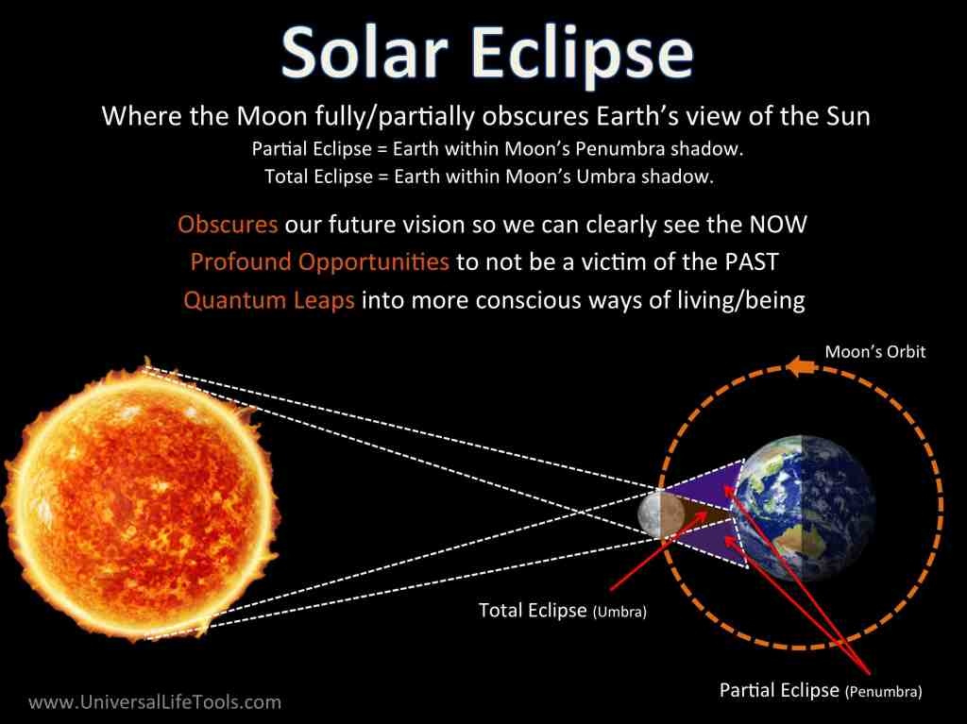
This Photo by Unknown Author is licensed under CC BY

On Monday, April 8, 2024, there will be a solar eclipse when the Moon moves between the Sun and the Earth. In Toronto, it is expected to be a near-total solar eclipse between 2:04 p.m. and 4:31 p.m., with the peak happening at 3:19 p.m. That’s when most of the Sun’s light will be covered by the Moon. Since this occurs when many people are returning home from school or work, it is important to plan ahead and take precautions.

Dangers of Viewing the Solar Eclipse Without Proper Eye Protection
Staring at the sun without protection may cause solar retinopathy , which is damage to your retina – the tissue at the back of your eye. Your retinas do not have pain sensors to signal damage from staring at the sun.
Symptoms may only surface 12 to 48 hours later and could involve retinal burns, temporary or permanent vision loss, and blurred vision. Unfortunately, once symptoms start, it is usually too late to reverse any resulting damage.
If you experience any changes in your vision following the solar eclipse, go to a hospital or your optometrist to be assessed. Do not drive.

